JOINS

We can retrieve data from two or more tables together using:

1. Joins
2. Set Operators

Join is used to combine data/rows from two or more tables, based on a related (common) column/field between them. i.e., Join combines two tables row wise based on matched common (related) column.

‘ON’ is used to specify/equalize common columns from both tables (Except Cartesian Join which do not use ON clause).

Cross Join (Cartesian Product):

Displaying all the possible combinations of data/rows between tables (i.e., It returns the cartesian product of the tables involves in join)

Cross join takes each record from left table and associate it with every record of right table.

Cross join queries do not have ‘On’ Clause.

**TblEmp (Id, Name, Gender, Salary, DpId)**

**TblDpt (Id, DptName, Location, DptHead)**

E.g.: Select Name, Gender, Salary, DptName from TblEmp Cross Join TblDpt

Select Name, Gender, Salary, DptName from TblEmp Cross, TblDpt

Total number of rows in cross join:

Let say TblEmp has 10 rows and TblDpt has 4 rows

Then , TblEmp cross join TblDpt will have – 10 x 4 = 40 Rows

Inner Join or Join:

Inner join returns only the matching rows between the joining table.

Non-matching rows are eliminated (ignored).

Inner join combines all rows from both the tables where condition specified by on satisfies i.e., value of common field is same.

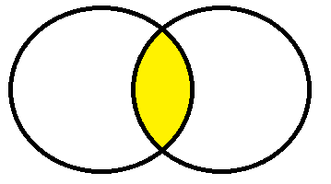

**TblEmp (Id, Name, Gender, Salary, DpId)**

**TblDpt (Id, DptName, Location, DptHead)**

E.g.: **Select** Name, Gender, Salary, DptName from TblEmp **join** TblDpt

**On** TblEmp.DptId = TblDpt.Id

OR

**Select** Name, Gender, Salary, DptName from TblEmp A **inner join** TblDpt B

**On** A.DptId = B.Id

Left Outer Join/Left Join:

Left Join returns all rows from the left table and matched records/rows from the right table. The rows from the left table for which there is no matching rows on right side will contain null and the rows from right table for which there is no matching rows on left side will be ignored (i.e., non-matching rows from right table will be eliminated).

(Or left outer join returns all the matching rows + non-matching rows from the left table & only matching rows from right table)

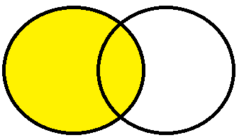

E.g.: Select Name, Gender, Salary, DptName from TblEmp Left Outer Join TblDpt

On TblEmp.DptId=TblDpt.Id

OR

Select Name, Gender, Salary, DptName from TblEmp Left Join TblDpt

On TblEmp.DptId=TblDpt.Id

Right Outer Join/Right Join:

Right Join returns all rows from the right table and matched records/rows from the left table. The rows from the right table for which there is no matching rows on left table will contain null and the rows from left table for which there is no matching rows on right table will be ignored (i.e., non-matching rows from left table will be eliminated).

(Or right outer join returns all the matching rows + non-matching rows from the right table & only matching rows from left table)

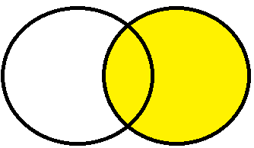

E.g.: Select Name, Gender, Salary, DptName from TblEmp Right Outer Join TblDpt

On TblEmp.DptId=TblDpt.Id

OR

Select Name, Gender, Salary, DptName from TblEmp Right Join TblDpt

On TblEmp.DptId=TblDpt.Id

Full Outer Join/ Full Join:

Full Join returns all rows from both tables (left table and right table) whether they are matching or not. The rows for which there is no matching records/rows will contain NULL.

‘ON’ is used to specify/equalize common columns from both tables.

i.e., Full Join returns all rows from both the left and right tables, including the non-matching rows.

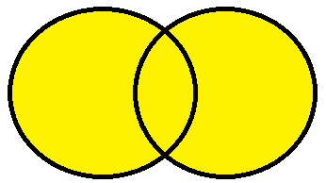

E.g.: Select Name, Gender, Salary, DptName from TblEmp Full Outer Join TblDpt

On TblEmp.DptId=TblDpt.Id

OR

Select Name, Gender, Salary, DptName from TblEmp Full Join TblDpt

On TblEmp.DptId=TblDpt.Id

Getting non-matching records only between tables

**Q. How to get only non-matching rows from left table, right table and both the tables?**

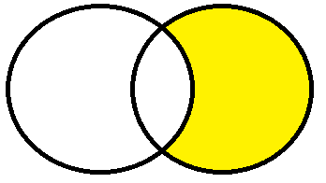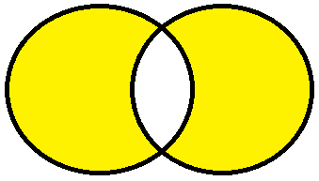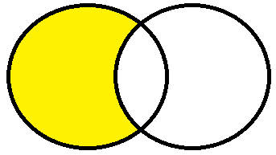

1. **Non matching rows from Left table**

Select Name, Gender, Salary, DptName from TblEmp Left Outer Join TblDpt

On TblEmp.DptId=TblDpt.Id

Where TblDpt.Id is NULL

1. **Non matching rows from Right table**

Select Name, Gender, Salary, DptName from TblEmp Right Outer Join TblDpt

On TblEmp.DptId=TblDpt.Id

Where TblDpt.Id is NULL

1. **Non matching rows from Right table**

Select Name, Gender, Salary, DptName from TblEmp Full Outer Join TblDpt

On TblEmp.DptId=TblDpt.Id

Where TblDpt.Id is NULL or TblEmp.DptId is NULL

Self Join:

Self join is to join a table to itself i.e., joining a table with itself is called self join.

Self join is basically an inner join where left table and right table is same.

Self join classification

1. Inner self join
2. Outer self join
3. Cross self join

|  |  |  |
| --- | --- | --- |
| **EmpId** | **EmpName** | **ManagerId** |
| 1 | Mike | 3 |
| 2 | Rob | 1 |
| 3 | Todd | Null |
| 4 | Ben | 1 |
| 5 | San | 1 |

1. Inner self join

Select L.EmpName as Employee, R.EmpName as Manager from

TblEmp L inner join TblEmp R

On L.EmpId=R.ManagerId

1. Left self join

Select L.EmpName as Employee, R.EmpName as Manager from

TblEmp L left outer join TblEmp R

On L.EmpId=R.ManagerId

1. Right Self Join

Select L.EmpName as Employee, R.EmpName as Manager from

TblEmp L right outer join TblEmp R

On L.EmpId=R.ManagerId

1. Cartesian Self Join

Select L.EmpName as Employee, R.EmpName as Manager from

TblEmp L, TblEmp R